Canvas Help Sheet

To access your child’s Canvas account, you will need to have him/her log-on. The following screenshots will help orient you.

For freshmen, you should see four courses and ECHS Home.

For sophomores, you should see three courses and ECHS Home.

View from DASHBOARD:

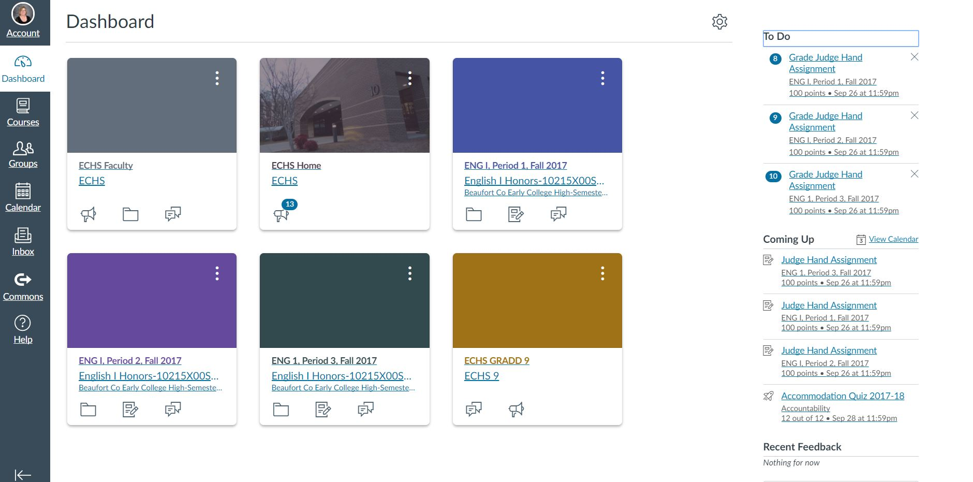

From this screen, you can navigate to the ECHS Home or core classes (ENG I, Periods 1,2,and 3 shown above) by clicking on the link located beneath the corresponding colored box.

Notice that on the left side, you can click on courses, calendar, the inbox, and help. (Note: Groups and commons are not available in student accounts). On the right side of the screen, you will see a TO DO heading of the student’s assignments and a COMING UP heading of student assignments.

View from ECHS Home page:

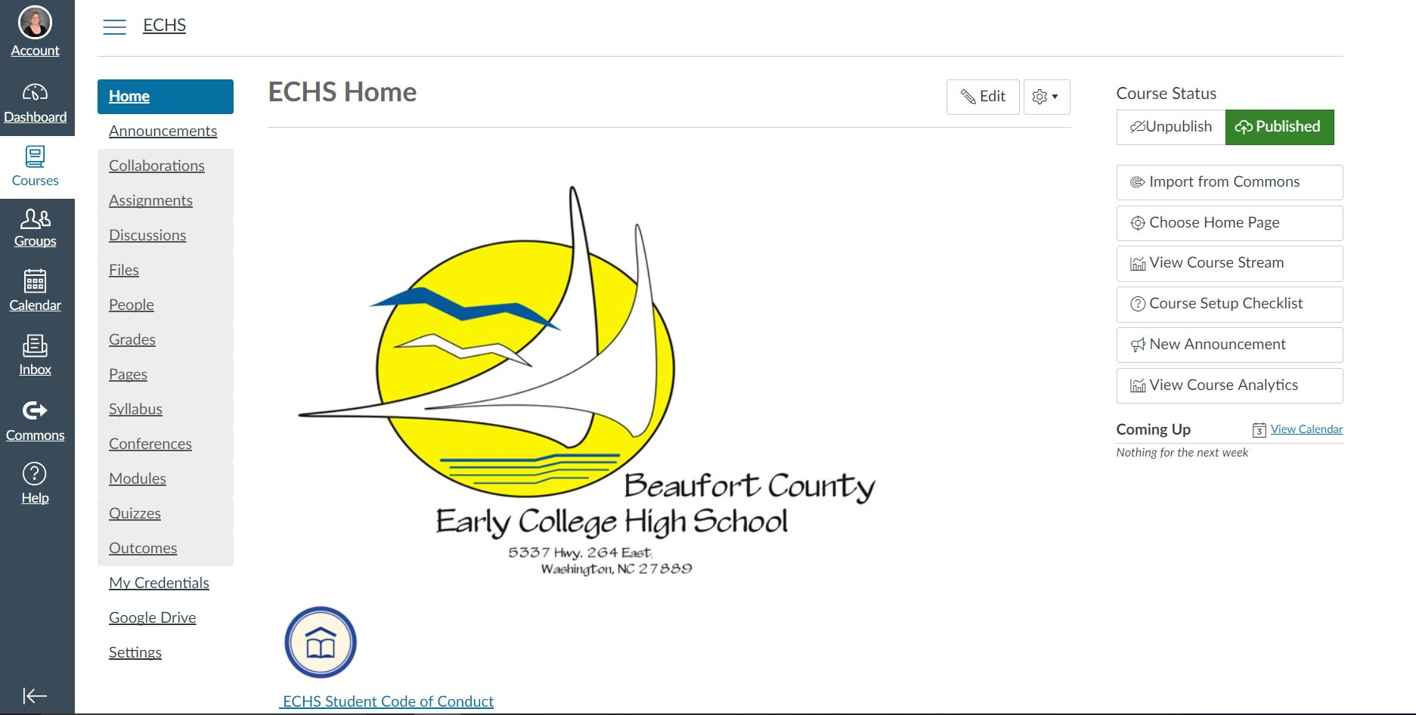

From this screen, you want to click on the ANNOUNCEMENTS link located on the left under the blue HOME box. The staff posts current information here for parents and students. ***Students should always check ANNOUNCEMENTS and COURSES for weather updates/school closures. We will post SATELLITE assignments in case of inclement weather.***

By scrolling down on the home page above, you will find various links. The first one is shown in the screenshot above (ECHS Student Code of Conduct). The school calendar, map and daily schedule are also located here (not shown in image above).

View from PEEK, ENGLISH I, Period One Home Page:

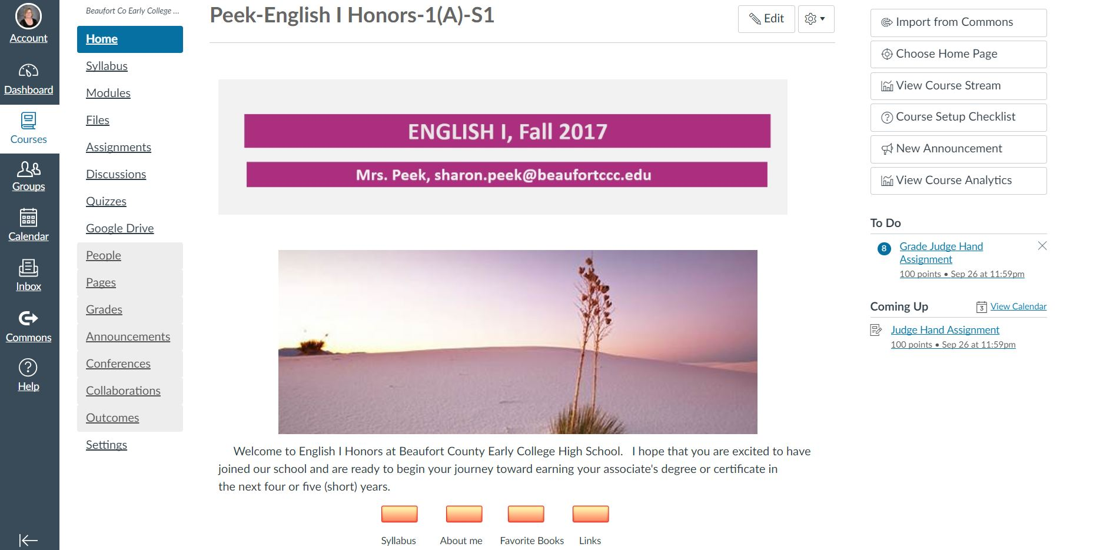

From this view (or other teacher/course pages), you will be able to use the navigation buttons on the left to access MODULES, FILES, ASSIGNMENTS, INBOX and others. On the right side, you will notice that the TO DO and COMING UP heading shows assignments posted in blue and can be clicked on for specific information. Individualized links may also appear on the page. (Teacher home pages will vary in appearance.)

View from a MODULE:

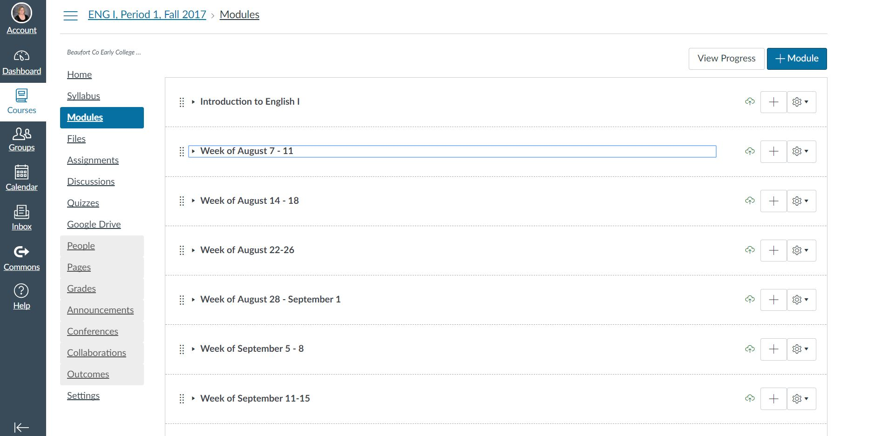

Some teachers will use modules to post in-class work, homework, reminders, etc. The arrangement of the module screen above can vary in appearance by teacher (daily, weekly, or by units of study). The screen above is arranged by week, and a pull down list of days will appear by clicking on the week.

Notice that you may navigate back to the home screen or other links. These are just a few of the page views available in Canvas to help you get started.